ASSEMBLAGE ART PROJECT Date Due______________________
Find 10-12 small things that are junk. Things that people might throw away. Look at the list. Put them in your bag. Bring them to school by the due date above.
Bring ANYTHING that has a cool shape. It needs to be very small.
You won’t bring it back home like it is. It will be painted. Don’t bring keys or other things if they might be important. Your parent needs to say it is okay to bring the things in your bag.
Don’t make your parent find things for you. You can do it. It is fun. Look for broken toys and things. Here are some ideas:
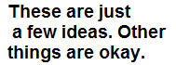
Buttons
broken toy parts
paper clips
shaped erasers
pen caps and parts old keys
broken chains
small pencils
plastic caps
plastic cord
bobby pins
old key rings
small shells
pop tabs
Lego parts
bottle caps dry pasta
nut shells
foamie shapes
broken zippers or zipper pulls
small plastic animals
broken hair clips
broken cheap jewelry
old puzzle pieces
alphabet beads
straws

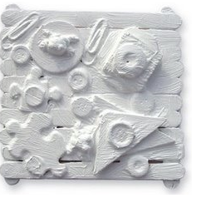
Things that don’t work: anything fabric or cloth, like fuzzy pompoms or feathers.

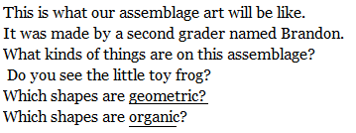

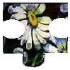
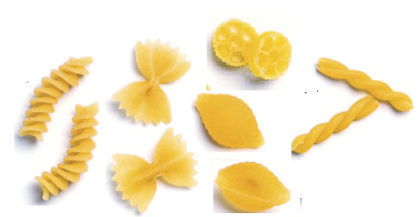
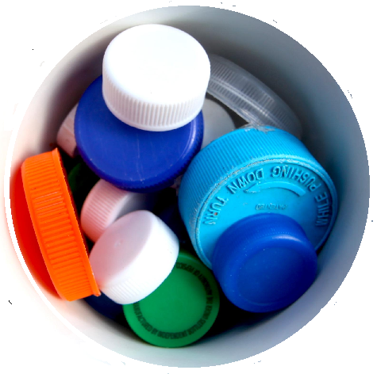
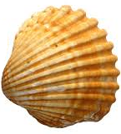
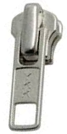
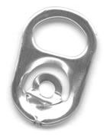
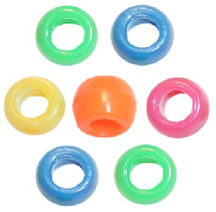
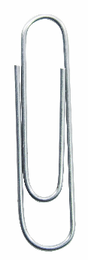
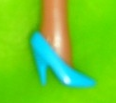
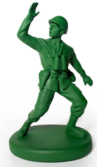
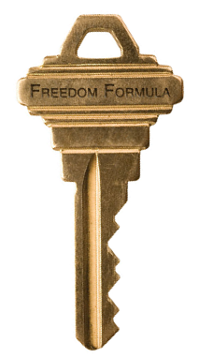
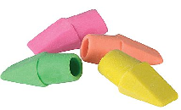

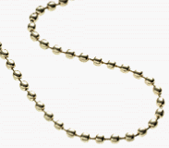

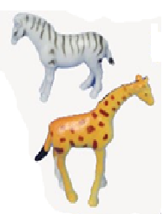
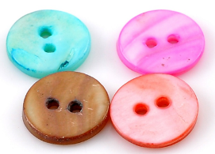
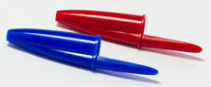
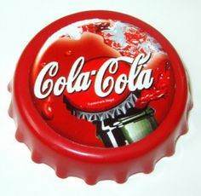
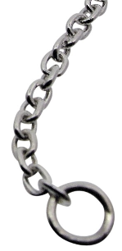
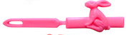
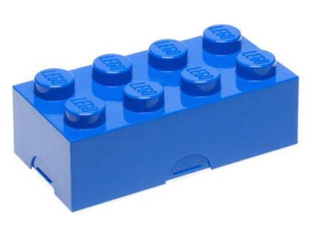
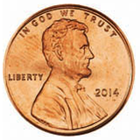
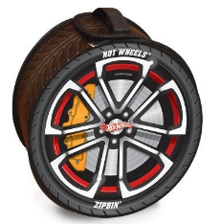

Louise Nevelson Found Sculpture
When Louise Nevelson was 7 years old she came to America from Russia. Her father worked with wood.. He cut trees for steam ships. Next to the lumber mill was a furniture factory. The furniture factory shaped wood for the legs of chairs and other furniture. Little Louis often played with the wood scraps from the furniture factory.

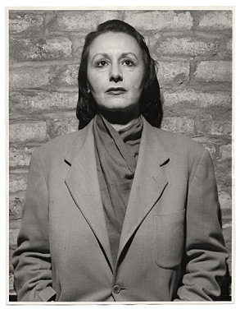
When she grew up Louise Nevelson wanted to be an artist. She wanted her art to be different. She wanted it to be special. She remembered the things she made from scraps when she was little. So she made art from wood scraps and other things that were thrown away.
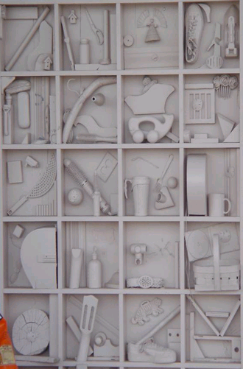

This is one of Louise Nevelson’s assemblages.
What things can you see in it?
It is painted all in white. Most of Louise Nevelson’s art is painted all black, all white or all gold.
Which shapes are geometric? Geometric shapes have names like square, oval, circle, rectangle and triangle.
Which are organic? Organic shapes usually don’t have names.
Why do you think she used just one color?

