2023-24 FAME Teacher’s Meeting Music Presentation

Cultural Focus: Scandinavia
Countries:
Sweden
Norway
Finland
Denmark

Iceland
Faroe Islands (Denmark)
Greenland (Denmark

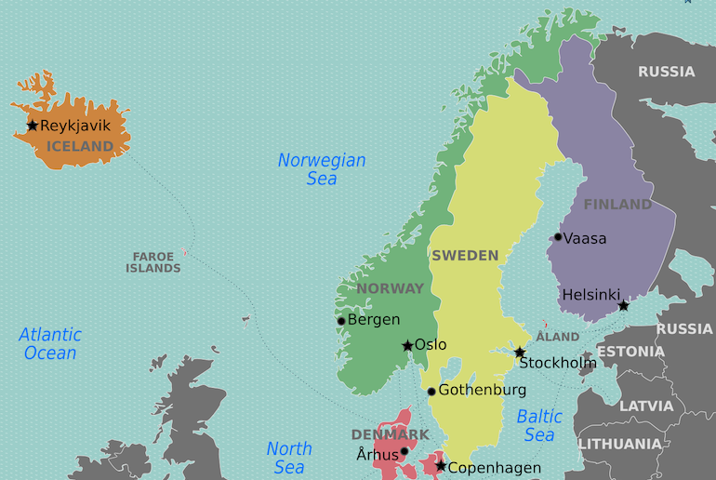
Fjäskern (Sweden)
From Teaching Movement and Dance by Phyllis Weikart – on Rhythmically Moving 2 or Shenanigans
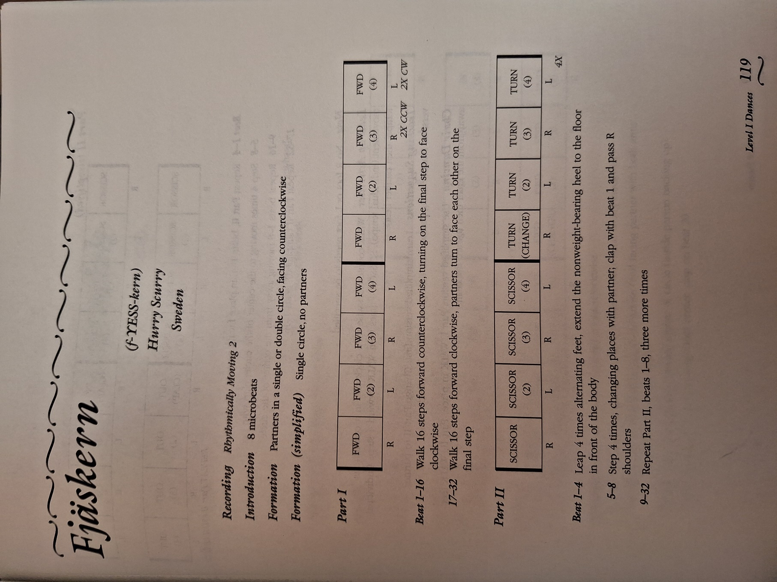

Undir grønum líðum (Faroe Islands – Denmark)

Under the green hills

A Faroese children's game.

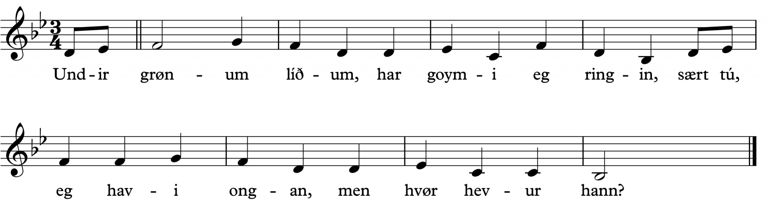
Undir grønum líðum,
har goymi eg ringin,
sært tú, eg havi ongan,
men hvør hevur hann?
Under the green hills,
I hide the ring.
You see I don’t have one,
but who has it?

Students sit in a circle with one in the center. All students hold their hands slightly open while the student in the center goes around and pretends to place a ring in each person’s hands, dropping the ring in one person’s hand. At the end of the song, the person who was last to “receive” the ring has some number of chances to guess who actually got the ring.
See the link in the PPT document for extensions.

Kuovsâkkâsah (Sámi – Lapland)

Northern lights

Composed sami-song in Livđe-style from Lapland about Northern lights
The Sami people are indigenous Finno-Ugric people living in parts of northern Norway, Sweden, Finland and the Kola Peninsula of Russia.
In Finland there are three Sami language groups and all of them have their own music traditions
1) North Sami have yoik or luohti
2) Skolt Sami have leu´dd
3) Aanaar Sami have livđe which is similar to yoik but sounds more like singing
1. North Sami yoiking is vocal music and traditionally no instruments are used. The songs are not only descriptive but try to capture the subject in their living sense. You can yoik a person, place (river, mountain, lake) or an animal (reindeer, bear, wolf). Yoik contains a lot of hidden rules. For example if the yoik is composed for a person, the composer does not own it but rather the person for whom the yoik was dedicated owns it. This means that this individual owns the “copyright” to his or her yoik. That is why some yoiks belong to certain families.
2. In Skolt Sami leu´dd the lyrics are important. Leu´dds tell how people lived. They are stories about the people and their culture. The melodies are simple. Many times the mood of the song is melancholic. Dance music is joyful. Typical Skolt Sami´s music are lullabies and vocal lament singing.
3. Aanar Sami livđe resembles North Sami yoiking but sound more like singing. Livđe have the same rules as north Sami yoiking.

Sheet music on next page.
See the link in the PPT document for extensions.

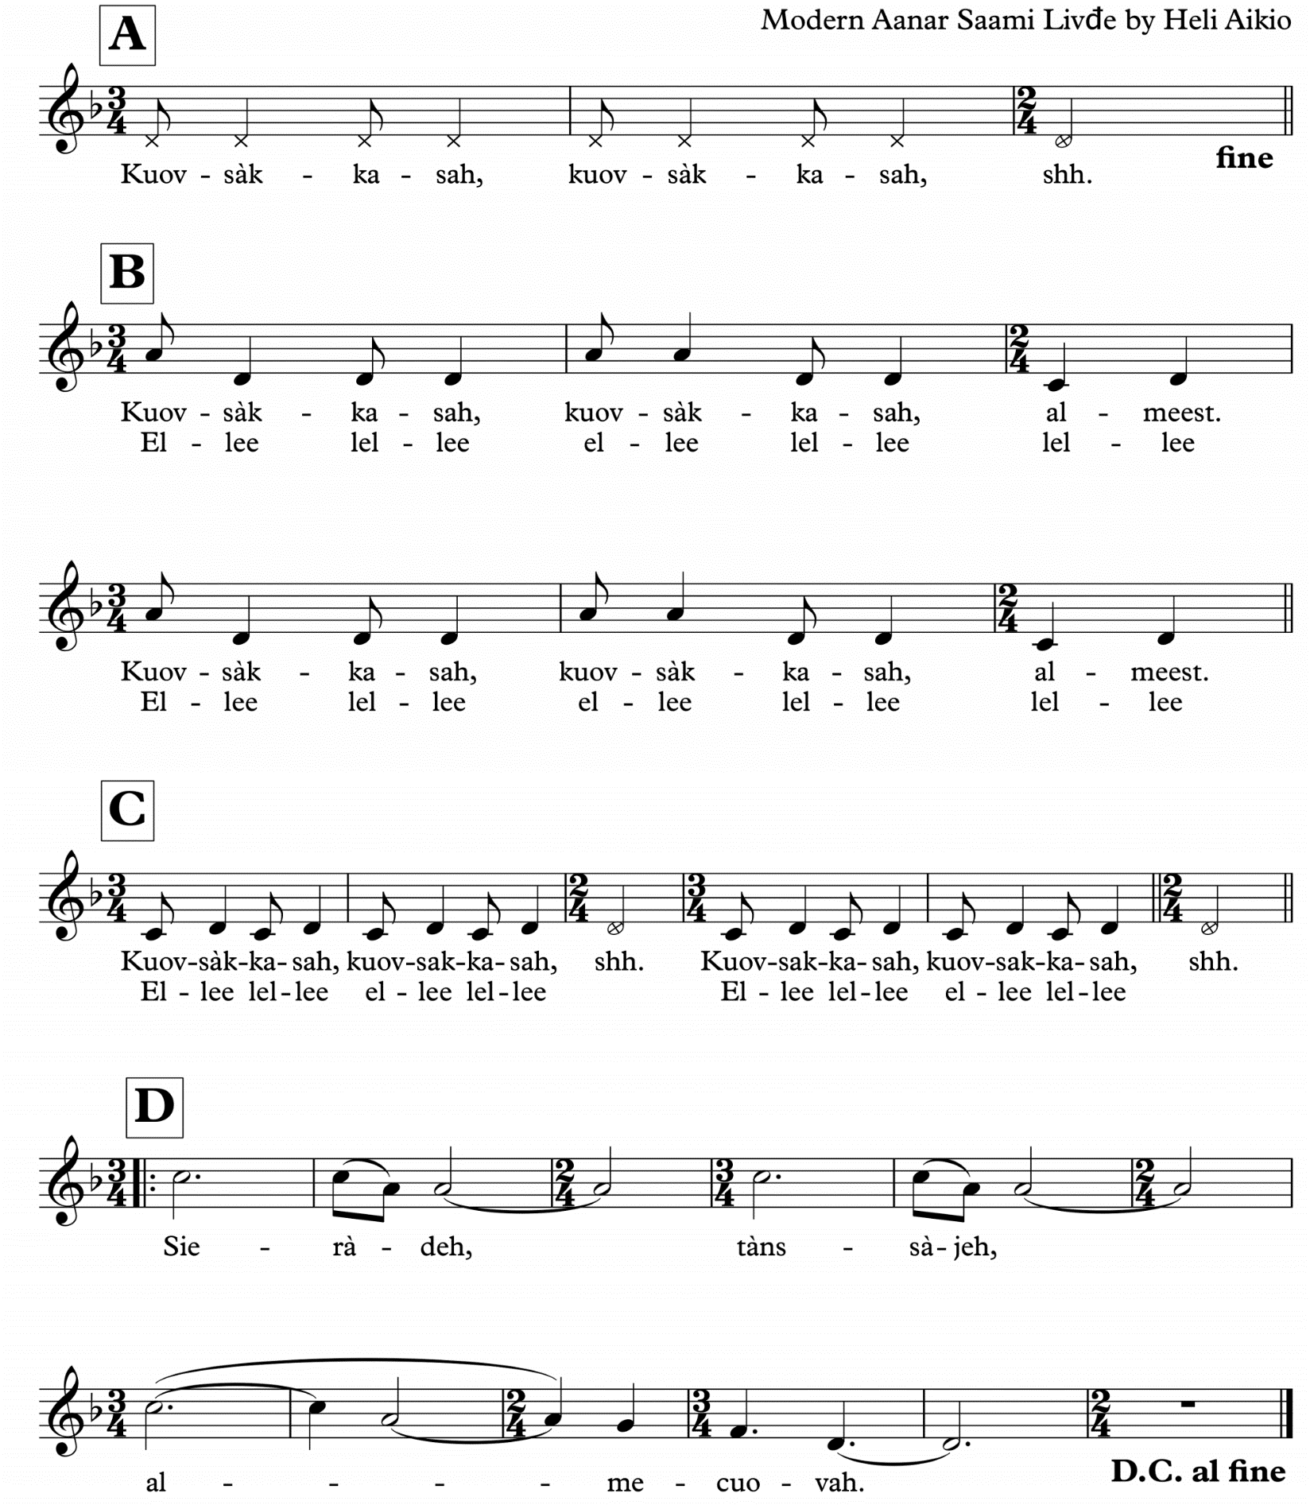
Onko koira kotona? (Finland)

Is the dog at home?

Finger game from Finland

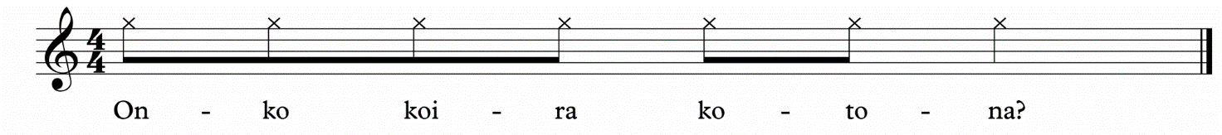
Trad. Finland

Q: Onko Koira kotona?
A: Miesten kanssa mettällä
Q: Onko Koira kotona?
A: Naisten kanssa navetassa
Q: Onko Koira kotona?
A: Lasten kanssa leikkimässä
Q: Onko Koira kotona?
A: HAU!
Q: Is the Dog at home?
A: No he’s with the man in the forest
Q: Is the Dog at home?
A: No he’s with the women in the barn
Q: Is the Dog at home?
A: No he’s playing with the children
Q: Is the Dog at home?
A: Hau! (Woof!)

The person providing the answers (A), tries to catch the other person’s finger (Q) between their fingers, when they bark ”HAU!”

Traditional game with two players
One person places their hands together. They spread their fingers apart so the other person can point inthe gap between each finger. As they point in the spaces they ask the question ”Is the Dog at home?”

See the link in the PPT document for extensions.

Pílaranda (Iceland)
Icelandic Children’s Game
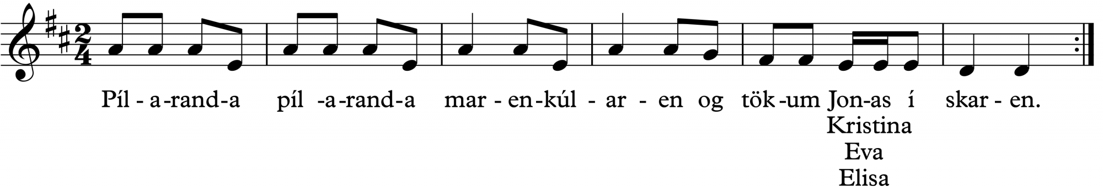

(nonsense)
(nonsense)
let’s take Jónas in the crowd
Last line:
release us all from the crowd.
Pílaranda, pílaranda
marenkúlaren
og tökum Jónas í skaren.
Last line:
leysum alla úr skaren.

Pílaranda (Peelaranda) is one of Iceland oldest children song-game and one of few that is purely Icelandic, most of them are originally from other nordic countries.
Four people stand in a circle holding both hands with the opposite partner to make a cross. One foot is in the front to maintain balance. Each group sings as the partners move in a rowing motion back and forth. During the last phrase, partners hold hands above the others to lift their right arms. While still holding hands, they take the partner to the right into the “skaren” (the crowd). Repeat this three times until everyone is inside. The last line is sung a fifth higher and the group dances quickly to the side.
On completion of the final phrase “let’s release all from the group” (skaren), each person releases the hand hold.
A variation with a larger group: Stand in a circle and the person being ‘called out’ turns 180 degrees without letting go of the partner’s hands. This is repeated until each person is facing outward. The final line of the song indicates that everyone turns back at the same time.
See the link in the PPT document for extensions.

Aqaat (Greenland – Denmark)
Charm song – for someone you love or care about
In Greenland, you often make a personal song for the one you love. These songs do not have a specific form or order. The purpose for this song is to show your love in the melody and the lyric. This can just be a sentence that shows your feeling or a melody with no words or a melody with nonsense words. The main purpose is to show your love for the person in the Aqaat song.
The character of the song can also be a reference to the personality of the receiver.
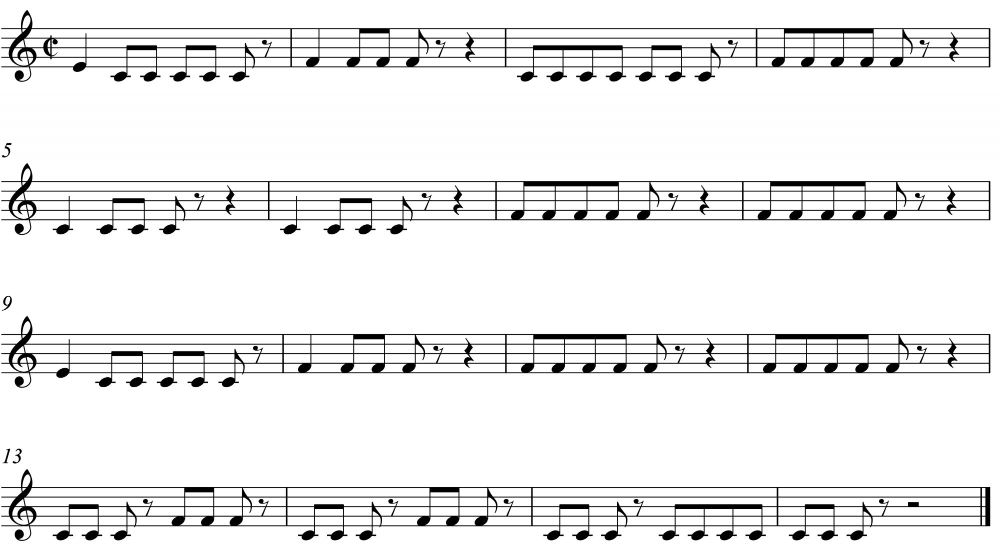
See the link in the PPT document for extensions.

Gustav’s Skol (Sweden)
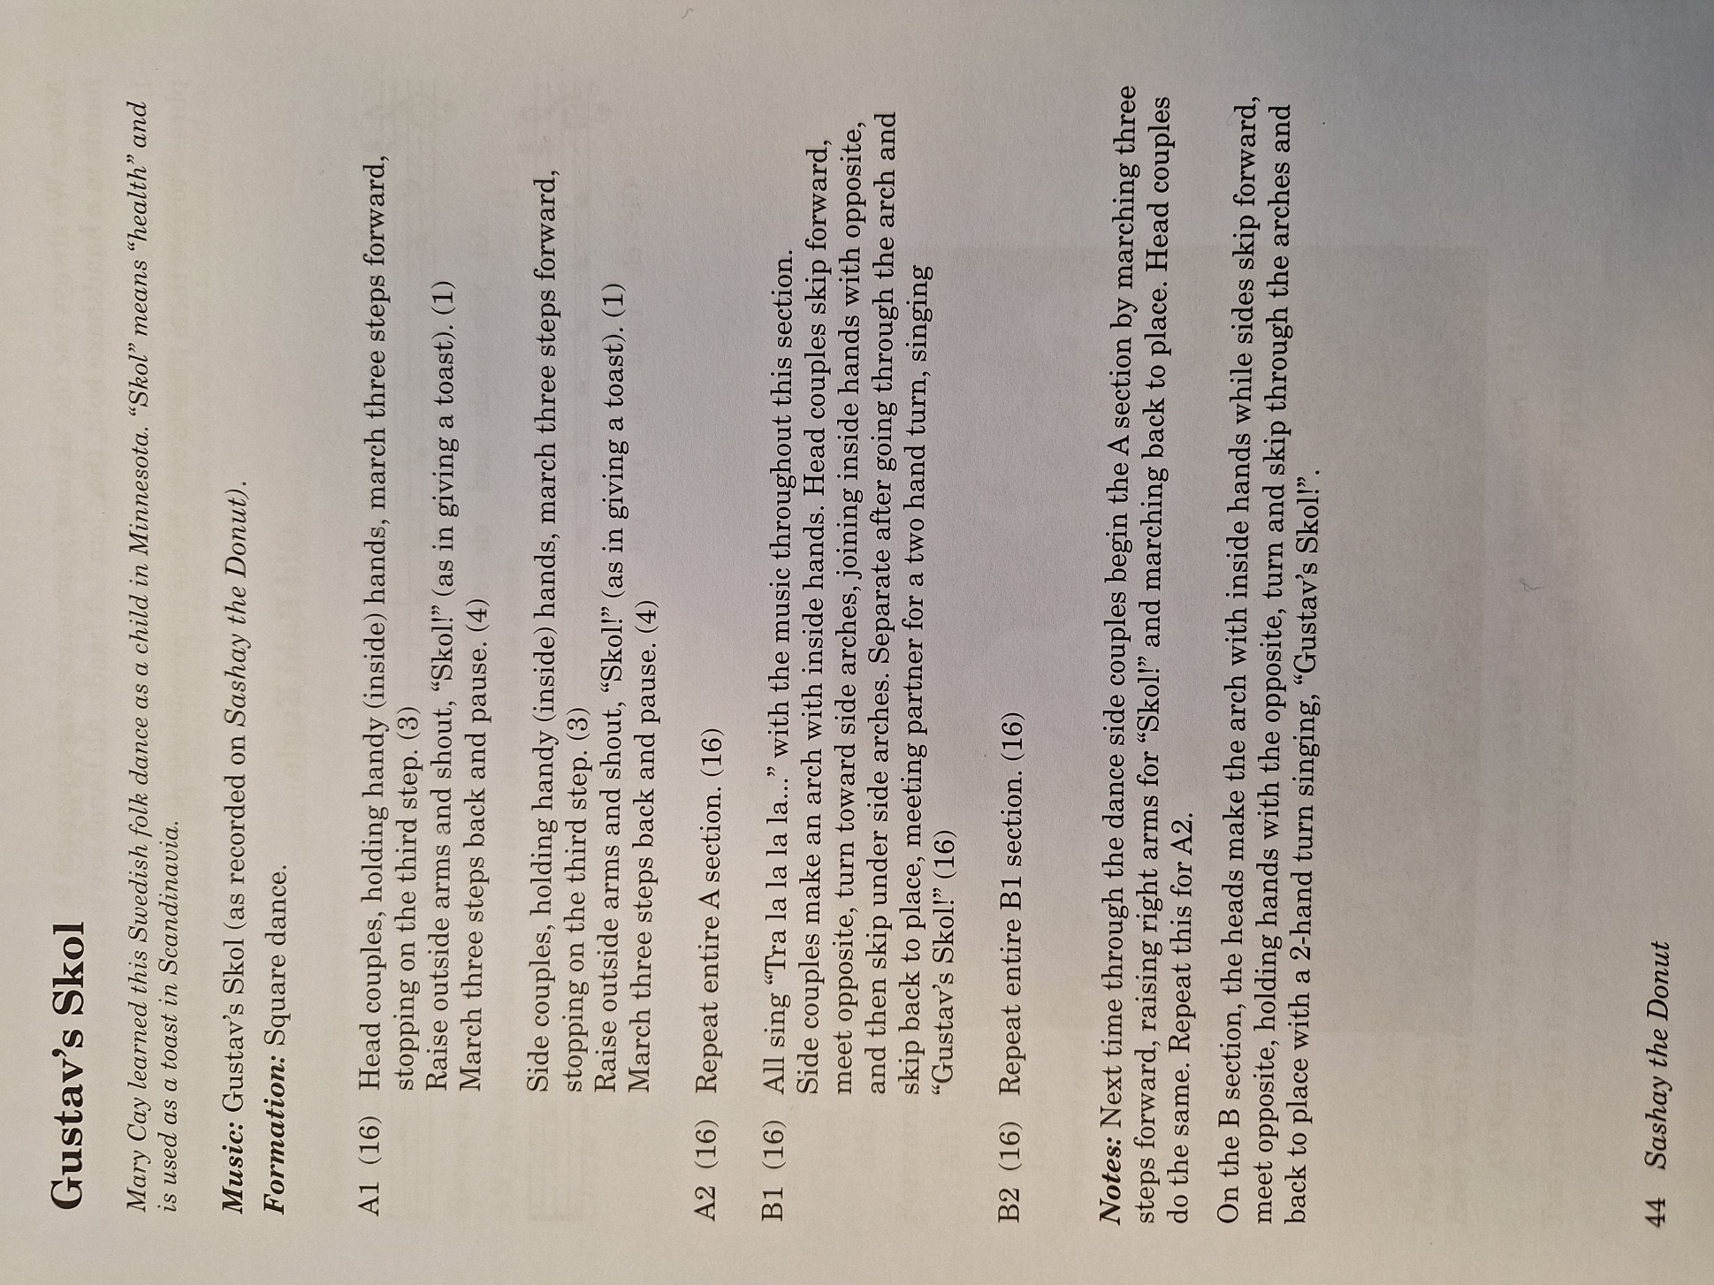
From New England Dancing Masters – Sashay the Donut
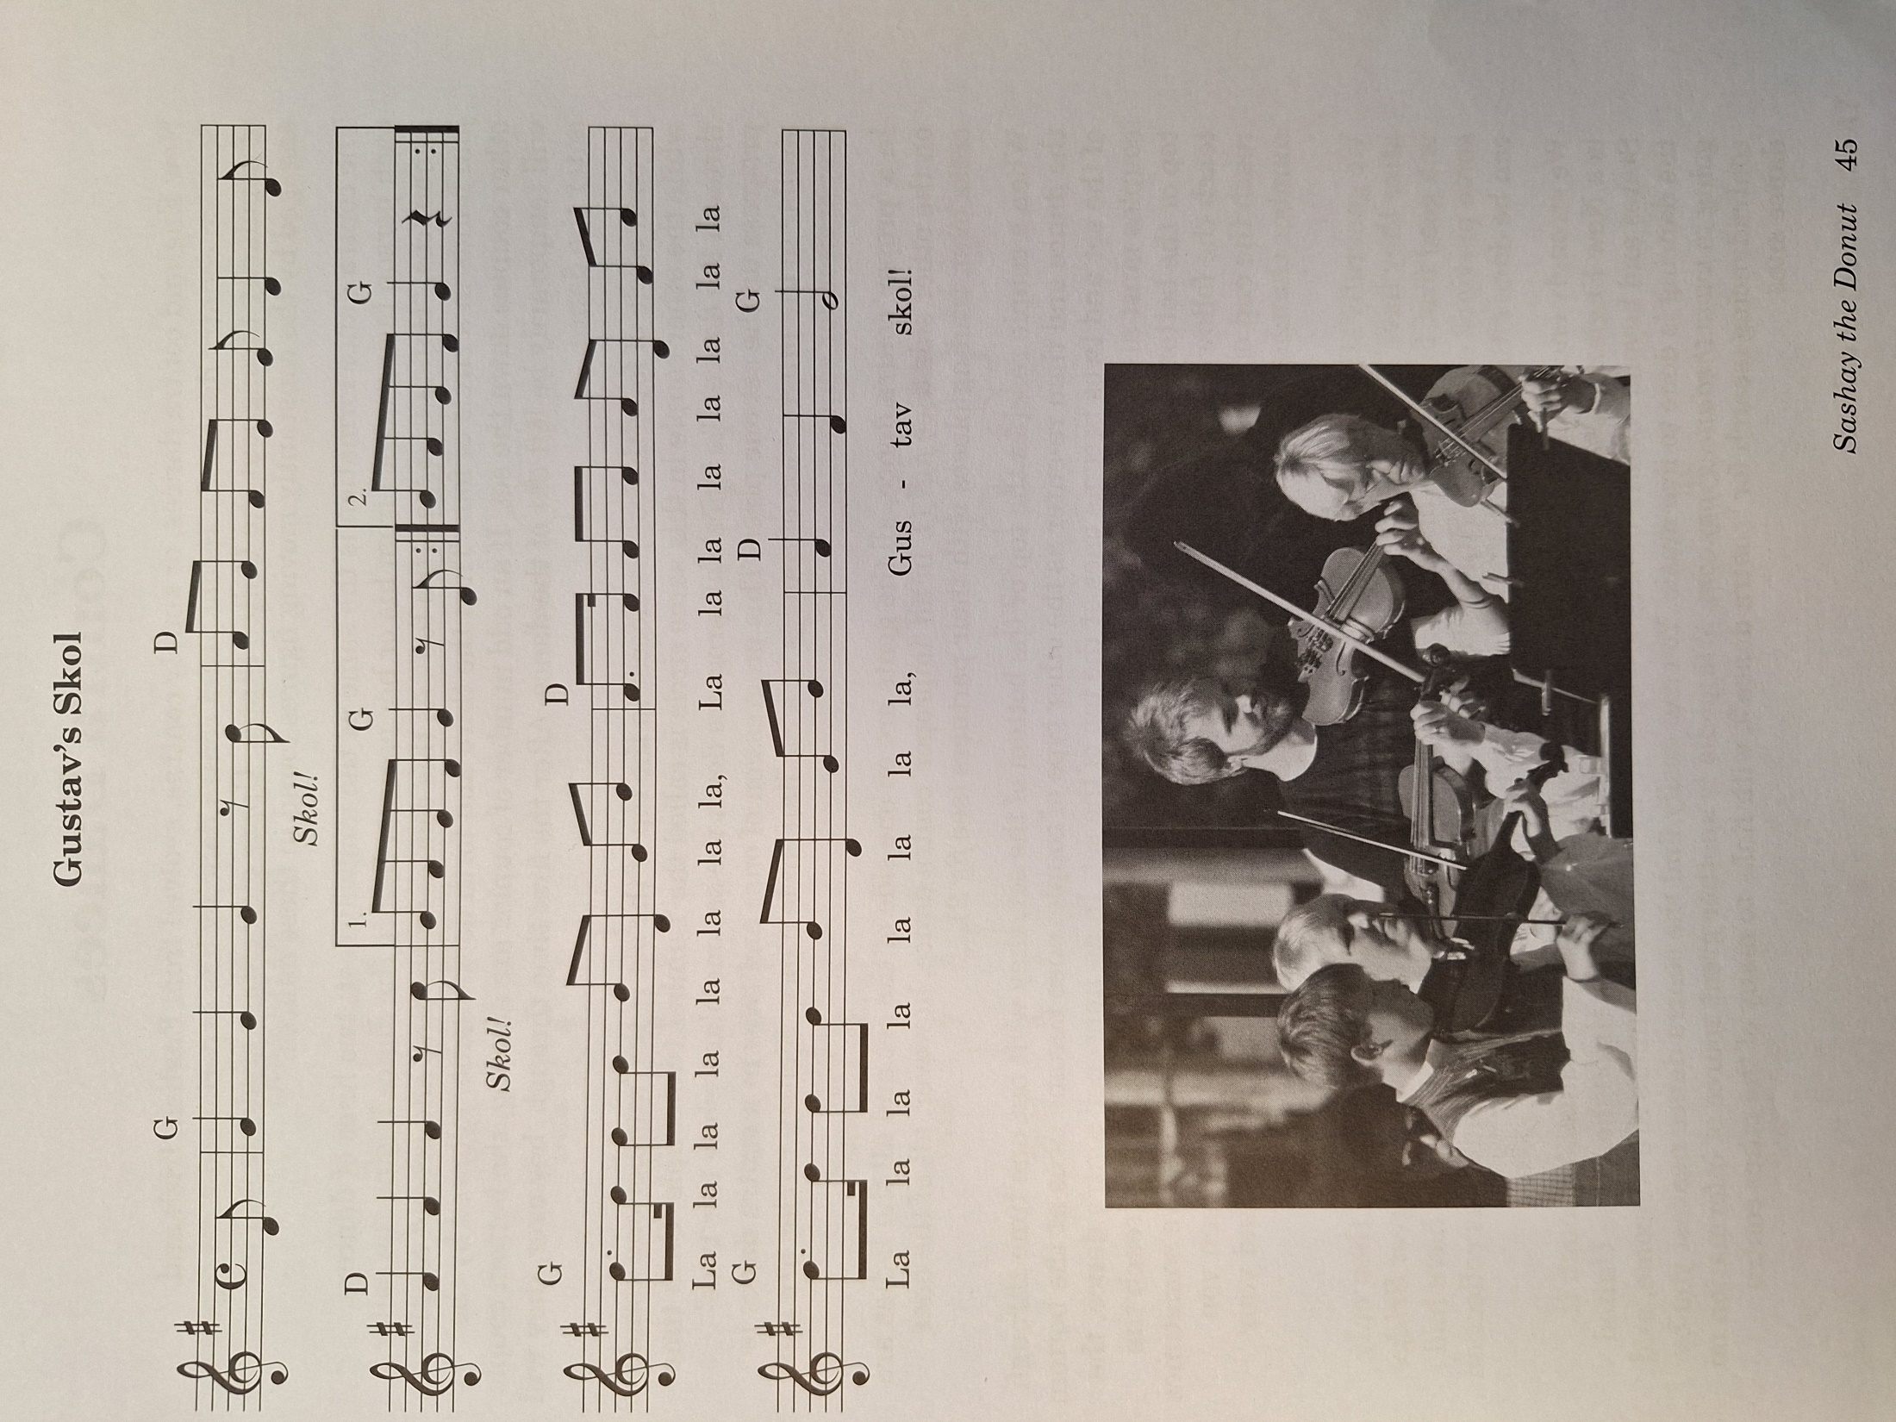
Seven Jumps (Denmark)
Danish folk dance.
Can be found on Shenanigans CD or on YouTube.
History:
“Seven Jumps” is a dance from Denmark that is still taught today. Reportedly, this was also a song that mocked the “topsy-turvy” career of a Danish politician. There is another dance of a similar name in Holland, called “De Zevensprong,” that has very similar dance motions its Danish counterpart.
While one cannot be sure of the dance’s exact origins or what the movements mean, it is fun to speculate the different contexts in which it existed. Some believe that it was about our above-mentioned Danish politician, while others think that it could have been part of a pagan religious ritual to help the corn crop grow taller. The higher dancers jumped, the better the crop would grow!
Formation:
Dancers begin facing inward in a circle.
Dancers walk in place or in a circle for 8 beats, then stop. Pat three times on knees, then clap three times. A long tone will sound, and students will lift one foot until the tone stops. This repeats, adding one long tone and one movement each time. The sequence is: lift one foot, lift the other, go on one knee, add the other knee, go down on one elbow, add the other elbow, lie on stomach.

Sulla Rulla

Norwegian lullaby.

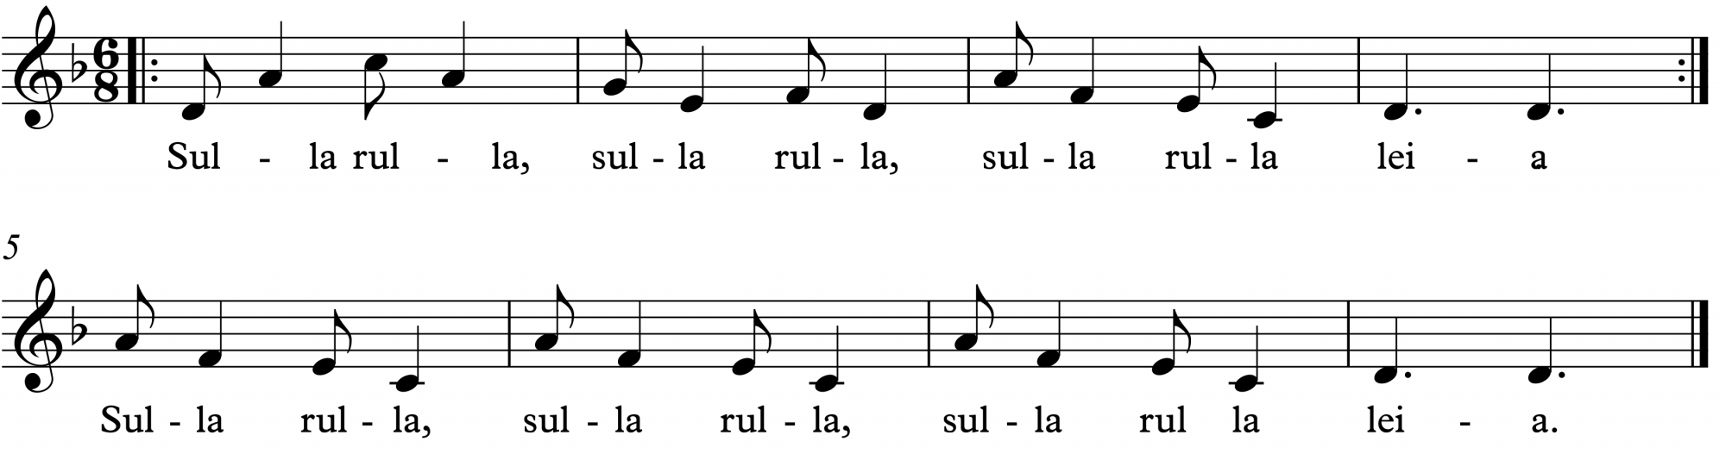

In Norwegian folksongs, they sing a lot on the consonants, so emphasize the sound of the L in Sulla rulla.

Eventually place the name of each child into the song instead of using ‘leia’ at the end of each line.

Sing while swaying together. Can be sung in canon. Can be given bordun. See link for extensions.

