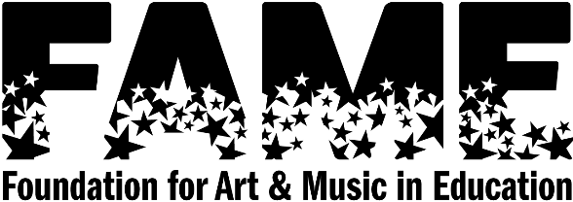
FOR OFFICE USE ONLY FOR COMMITTEE USE ONLY
Date Received __________ Sibling discount _____ % Reduction _____
Date Awarded __________ Assistance Awarded_____ Balance due _____

FAME Camp Participation Assistance Application 2024
The FAME Board never wants financial circumstances to be a barrier to participating in FAME Camp. Therefore, we are pleased to be able to offer a few scholarships to families who desire to send their child to camp. To fairly serve all families, the following information must be provided to the Camp Participation Assistance Committee. ALL information will be kept confidential.
Please return your application forms and attachments by June 15. All required documentation must be provided with the application to be considered.
Child’s Name _______________________________________________________
Parent/Guardian Name(s) ____________________________________________
Street Address ______________________________________________________
City & State _________________________ Zip ___________________________
Home Telephone ____________________________________________________
Email Address _______________________________________________________

INCOME Data: Please include any working parent/guardian, step-parent, etc. who contributes to the household income.
I have attached my previous year’s (2023) tax return (Form 1040) to this application.
If your family does not earn enough income to file Federal income taxes, please submit a proof
of income statement (W2, 1099’s, bank statement). If you have questions, contact the FAME office.
Any application submitted without this information will not be considered. No exceptions can be made.

Please indicate appropriate additional information:
Number of people claimed on tax return _____
Number of people in household _____

Please use the back of the application to provide a statement of need, including any extenuating circumstances that are contributing to your need for financial assistance (i.e. medical bills, parents returning to college).
Please read and sign below: In order to assist as many families as possible, full and partial Camp Scholarships are considered. Applications will be reviewed and your family will be notified in writing by July 1. Failure to comply with making your share of Camp payments in a timely manner or falsifying financial information, will result in forfeiting participation assistance funds.

Signed ______________________________________________________ Date __________________

Participation assistance funds are made possible through the generous donations of Sharon Ford’s Family. FAME strives to include all people regardless of their race, ethnicity, gender, orientation, ability, economic status, native language, religion, or any other aspect of their background.
FAME, 300 E Main Street, Fort Wayne, IN 46802— (260) 247 7325 info@famearts.org

