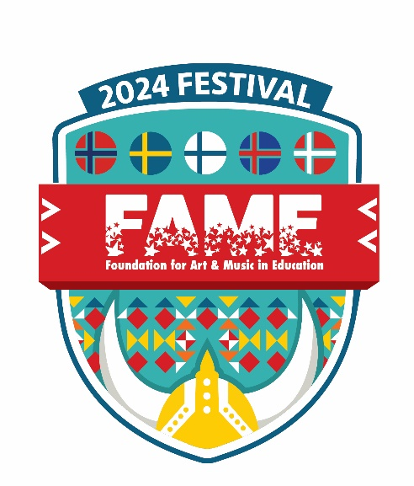
FAME Festival
March 16 and 17, 2024
Grand Wayne Center, Fort Wayne
School ______________________________________
Performance
Date ________ Time ________ Stage _____
Artboard #________ Sculpture Garden _________

Admission: $5 Adults, Children under 18 are FREE
Festival Hours at the Grand Wayne Center:
Saturday, March 16 – 9am to 5pm
Sunday, March 17 – 12n to 5pm
Parking: Civic Center Garage (paid w charge card) and on the street (free).
Celebration of Youth Concert with the Fort Wayne Philharmonic Youth Orchestra and the Fort Wayne Ballet Youth Company, March 16, 5pm Convention Hall Section C
Art exhibits and performances in song and instrumental from FWCS, NACS, SACS, EACS, West Noble, private and parochial schools will be represented
FAMEous Imaginarium with 12 hands-on-activities
Instrument Playgrounds – try out an instrument with Sweetwater Sound and Quinlan & Fabish
This is sure to be a joyous event – We can’t wait to see you at the FAME Festival!

